**Assignment – 3**

Table:

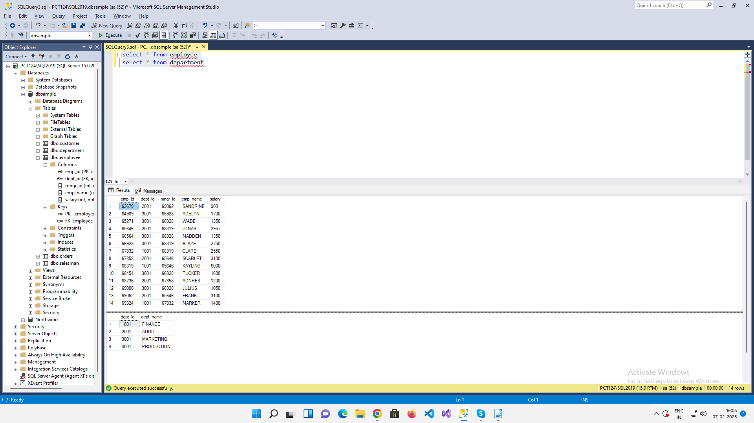

1. Write a SQL query to find Employees who have the biggest salary in their Department

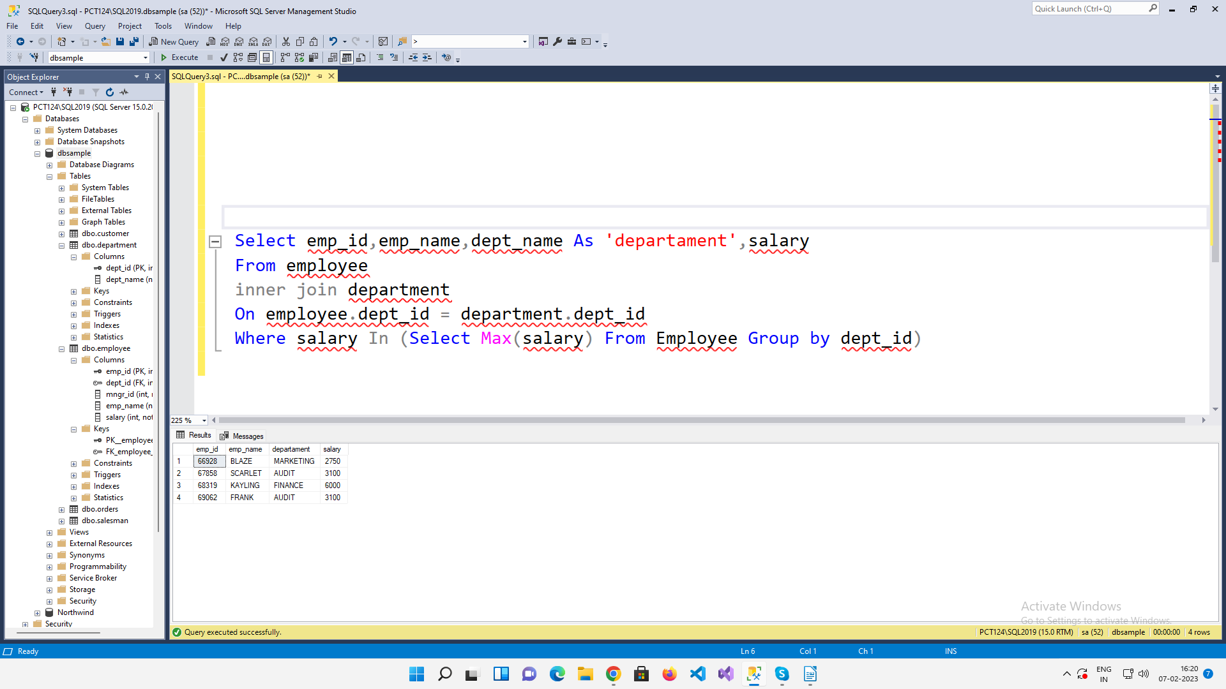

2. write a SQL query to find Departments that have less than 4 people in it

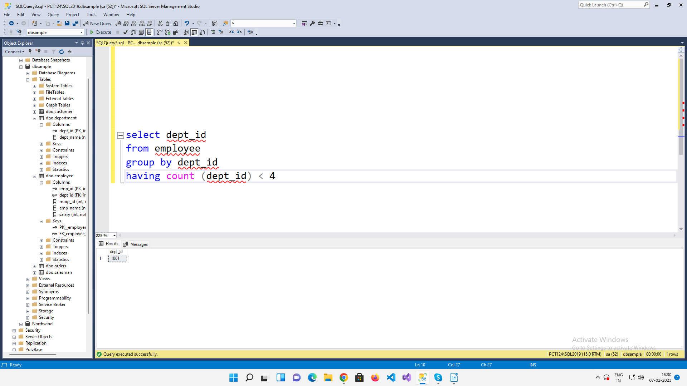

3. write a SQL query to find All Department along with the number of people there

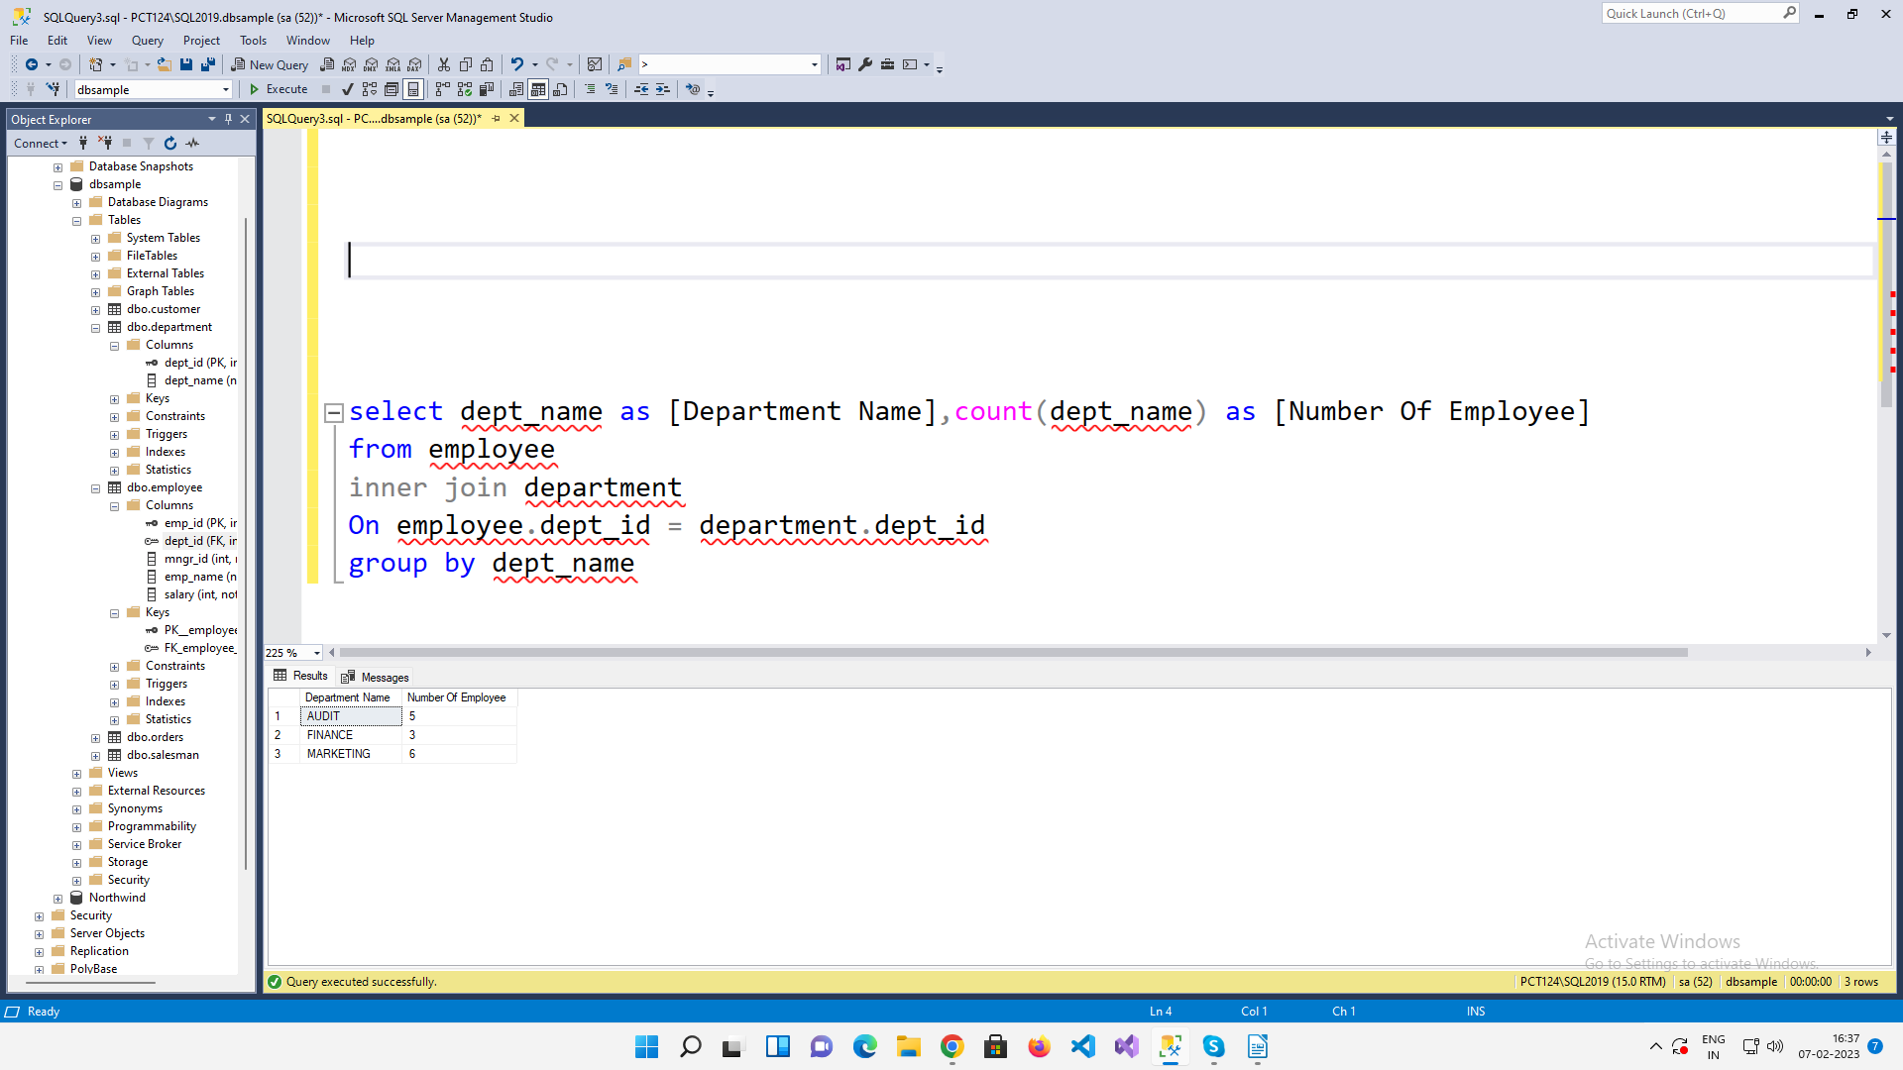

4. write a SQL query to find All Department along with the total salary there

